Melling Primary School Calculations Progressions
MULTIPLICATION
1)  Doubles up to 10  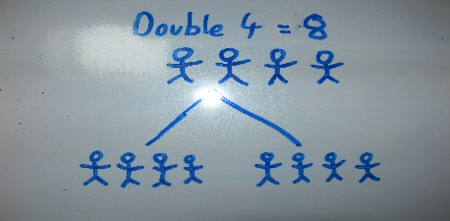 | 2)  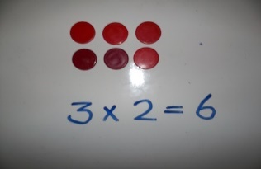  Using arrays up to 20
3)  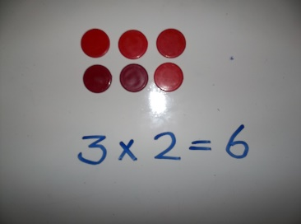  Using arrays up to 50 | 4)  Partitioning x by 2, 3 and 5 up to 100  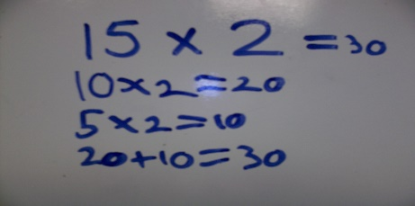
5)  Simple grid method TU x U using x2,x3,x4,x5  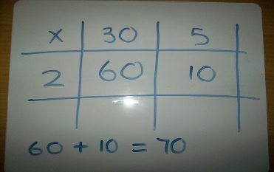 | 6)  Grid method TU x U using x2, x3, x4, x5, x6 x8  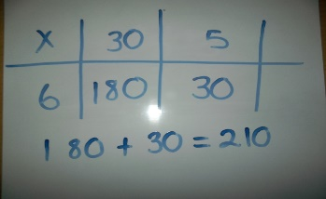
7)  Simple grid method using HTU x U using all tables  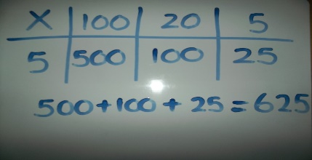 | 8) YEAR 4  Multiply 2 and 3 digits by a single digit  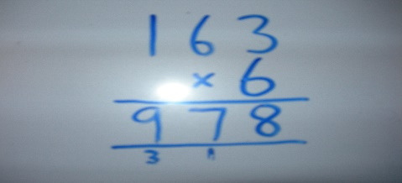
9)  Multiply a 3-digit number by 2-digit number   | 10)  Multiply a 4-digit number by a 2-digit number  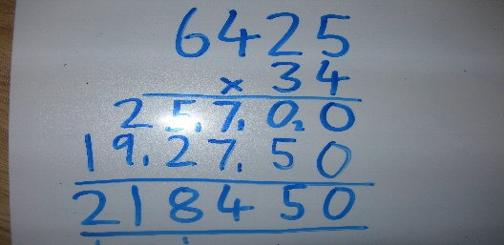
11)

Multiply a number with 2d.p. by a single digit



