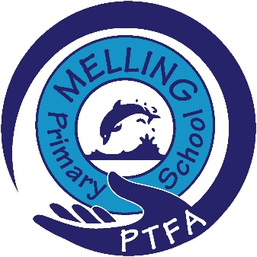
Christmas P.T.F.A fundraising raffle
Parents and Carers,
On Friday 12th December, we would like to kindly invite all children to come to school wearing a Christmas jumper/ top in place of their school jumper (full uniform as normal).
Could each child please bring in either a bottle (alcohol/ non-alcohol) or chocolates for our raffle prizes.
Raffle tickets will be available each day during school plays, as well as after school, both under the canopy on the playground and outside the junior gates from Thursday 11th. £1 a strip. These will be available until Wednesday 17th.
Winning ticket to be drawn Thursday 18th (party day).
Hampers will be available to collect from the office at the end of the day.
Prizes to be won in the hampers:
x2 photography vouchers worth £160 (one-hour family session) as well as a complimentary photo.
Various pamper sets*
Sweets/ chocolates*
Range of drinks (including alcohol)*
x2 £10 hairdressing vouchers
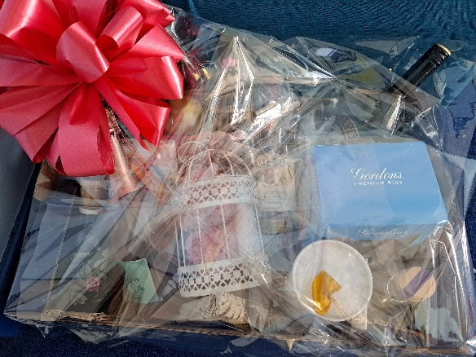
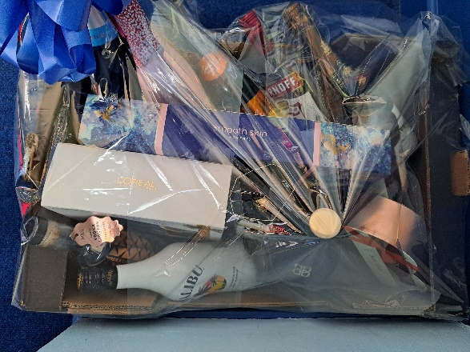

*pictures from previous raffles – items may vary for 2025 hampers
Good luck to all!

