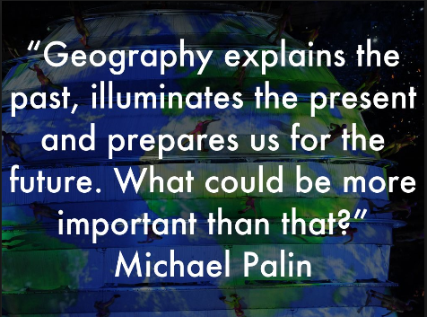
THE MELLING APPROACH TO GEOGRAPHY

‘A high-quality Geography education should inspire in pupils a curiosity and fascination about the world and its people that will remain with them for the rest of their lives. Teaching should equip pupils with knowledge about diverse places, people, resources and natural and human environments, together with a deep understanding of the Earth’s key physical and human processes. As pupils progress, their growing knowledge about the world should help them to deepen their understanding of the interaction between physical and human processes, and of the formation and use of landscapes and environments. Geographical knowledge, understanding and skills provide the frameworks and approaches that explain how the Earth’s features at different scales are shaped, interconnected and change over time.’
National Curriculum 2014

AIMS:
- To enable children to gain knowledge and understanding of places in the world; learning about their own area and comparing life in this locality to other regions in the UK and the rest of the world.
- To increase children’s knowledge of other cultures and, in doing so, teach a respect and understanding of what it means to be a positive citizen in a multi-cultural country;
- To allow children to learn graphic skills including how to use, draw and interpret maps;
- To enable children to know and understand environmental problems and world events at a local, regional and global level;
- To encourage in children a commitment to sustainable development and an appreciation of what ‘global citizenship’ means;
- To develop a variety of other skills including those of enquiry, problem solving, ICT, investigation and how to present their conclusions in the most appropriate way;
- To acquire skills in carrying out observations and in collecting, organising, recording and retrieving information as part of an enquiry. To be able to use a variety of sources to find information. To be able to communicate their findings in various ways.

OUR HIGH-QUALITY TEACHING APPROACH:
- Ensure that pupils are able to make use of their prior learning in moving their geographical understanding forward; as a result lessons are stimulating and often innovative with geographical rigour at their core.
- Is planned with assessment criteria in mind.
- Builds and promotes an atmosphere in which Geography lessons provide opportunities for children to explore, discover and interact with the world in which they live and understand how it came to be the way it is.
- Uses a variety of strategies which cater for pupils who learn in different ways.
- Involve practical activities and field work wherever possible.
- Teachers takes note of any relevant research on children’s misconceptions which may influence their teaching.
- Has a Geography Wow Moment in each lesson
- Gives pupils the opportunity to demonstrate their curiosities: question, analyse, and think critically.
- Offers pupils the opportunities to display/record their results in various ways e.g. maps, charts, written accounts, letters.
- Allows children opportunities to plan and carry out their own research.
- Links to other subjects where they overlap naturally.
- Makes links at a range of scales from the local to the global.
- Uses quality and up to date resources.

OUR APPROACH:
In Melling Primary School, we teach Geography, from Reception to Y6, using the KAPOW scheme of work. Kapow Primary’s Geography scheme of work is built around the following four key areas:
- Locational knowledge – naming and locating places and features from memory; using atlases, globes and maps.
- Place knowledge – developing a sense of the children’s place in the world; comparing and contrasting geographical areas to understand their characteristics and cultures; learning how places are interconnected and change over time.
- Human and physical geography – understanding the relationship between humans and the environment; exploring the Earth’s natural features and processes; considering the impact of human activity on settlements; learning about land use, trade and natural resources.
- Geography skills and fieldwork – using maps and diagrams; describing location and direction; planning and carrying out fieldwork enquiries.
Kapow Primary’s Geography scheme of work aims to inspire pupils to become curious and explorative thinkers with a diverse knowledge of the world – in other words, to think like geographers. The intention is for pupils to develop the confidence to question and observe places, measure and record necessary data in a variety of ways and analyse and present their findings.
The scheme aims to build an awareness of how Geography shapes lives at multiple scales and over time. The hope is to encourage pupils to become resourceful, active citizens who will have the skills to contribute to and improve the world around them.
The scheme supports teachers in developing their subject knowledge and skills, enabling the delivery of engaging, well-informed lessons with confidence. The curriculum is designed to be both accessible and ambitious, ensuring all learners’ full participation and potential achievement.

The three elements in high-quality geographical work
Enquiry, geographical  skills and fieldwork | Asking and answering questions  Planning and undertaking geographical enquiries  Communicating the outcome of enquiries  Making and using maps  Using globes, atlases and digital mapping  Fieldwork skills  Using secondary resources such as books, websites and images  Understanding differing points of view
Studying places place & locational knowledge | The school grounds and local area  The UK, Europe and the wider world  Localities in the UK, Europe and the wider world  Locational knowledge
Physical, human and  environmental Geography | Physical Geography  • landscapes, volcanoes, rivers, coasts  - the weather, seasons and climate  - landscapes, plants-and animals  Human Geography  - homes, buildings, villages, towns and cities  - journeys and the movement of people, goods and Ideas  - jobs, agriculture, fishing, mining, manufacturing, transport, services  - land use and the location of activities  Environmental Geography  - change and development  - caring for the environment and the planet sustainability and environmental responsibility
(Source: GA The Everyday Guide to Primary Geography: Fieldwork)

Lesson Plan Model for Melling’s Geography
Anticipatory Set | - Engage pupils | WOW/Hook – video, music, food, speaker, items from the country
Anticipatory Set | - Connect with prior learning | From previous year or previous lessons; from other subjects as well as Geography to aid memory.
Anticipatory Set | - Explain what students will learn
Anticipatory Set | - Connect to future learning | Tell students what they are going to learn about in the topic.
Introduction of new material | - Provide instructions  - Model new skills  -Check for understanding | Depending on lesson, this may be structured or more enquiry based for pupils.  (Opportunity for ‘I model’)
Guided Practice | Facilitate student work | (Opportunity for ‘we model’)
Independent Practice | Assign independent class work or homework | (Opportunity for ‘You model’)
Closure | Have pupils briefly summarise their learning | Could be verbally or written so all can summarise.  Could take form of a quiz.

CURRICULUM MAP:
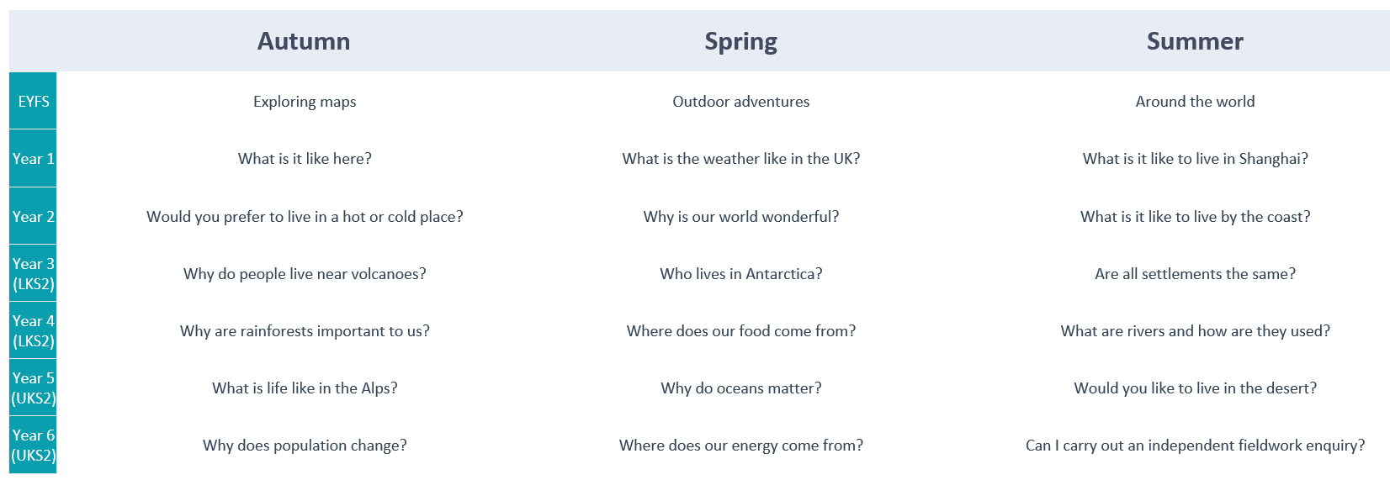

Inclusion
At Melling Primary, Geography forms part of a broad and balanced inclusive curriculum which provides all children with relevant and challenging learning. Through each topic taught, suitable learning challenges are set in response to children’s diverse learning needs.
ADAPTIVE TEACHING: At Melling Primary, the main body of teaching is aimed at enabling the vast majority of pupils to access and accommodate concepts, skills and methods at an age-related expectation. Children identified as SEND may have a tailored Geography curriculum that incorporates some aspects of age-related expectations but will also incorporate vital concepts from previous year groups that have not been fully grasped.

Enrichment
In each year group, learning is enriched through high quality resources, visitors, school trips and fieldwork opportunities. Children are able to use maps, atlases, the internet and watch videos to ask and answer questions about the topics they are learning. We have subscription to Oddizzi which really brings Geography to life and all children have their class login to use at home. Whole school theme days and quizzes take place to raise the profile of Geography across the school and to motivate and engage children to love learning about the world.
Children in Y4 and Y5 experience geographical enhancement during their residential in Crosby Hall Educational Trust when they engage in orienteering using map skills.
YR, Y1 and Y2 classes will have cuddly bears to help them with the retrieval of geographical knowledge and skills. Each KS2 class have a set of compare bears for retrieval activities at the start of a lesson eg put a bear on the continent of Asia, put a bear on the equator etc.
Show what you know days are planned in Geography for children to demonstrate the skills and knowledge they have learnt.

ASSESSMENT IN GEOGRAPHY:
Kapow Primary Geography lessons include ongoing assessment opportunities, such as questioning, retrieval practice and interactive activities. These enable teachers to assess understanding in real time and adapt their teaching accordingly.
Teachers will assess children’s geography by making informal judgements during lessons through questioning, pupil discussions, pupils work or asking pupils to summarise what they have learnt by writing a sentence at the end of the lesson. On completion of a piece of work, the teacher will assess it against age-related learning objectives, and then use this assessment to plan for future learning. Written or verbal feedback is given to the child to help guide his/her progress. Older children are encouraged to make judgements about how they can improve their own work. For all KAPOW topics, end of unit assessments are available for pupils to see what they can recall and allow teachers to assess the knowledge gained. A record of how children are achieving the learning objectives is kept in the front of their exercise books. This data is used to report achievements to parents at the end of the academic year.

MONITORING:
The monitoring of teaching and learning in Geography takes place through book scrutiny, lesson observations, show what you know sessions and pupil interviews to ensure coverage, continuity and progression in Geography.
Findings are used to inform future planning and possible CPD for staff to enhance teaching and learning in the future.
A subject leader report is presented to Governors in the Summer term.
Mrs Hargreaves is the subject lead for Geography.

Policy updated April 2026
Policy Review April 2027

