Melling Primary School Calculations Progressions
ADDITION
1)  Combining two or more sets of objects up to 10  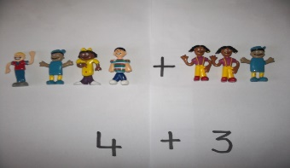 | 2)  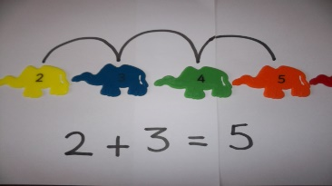  Add using a numberline up to 20 and beginning to record
3)  Add by counting on up to 20 without a numberline  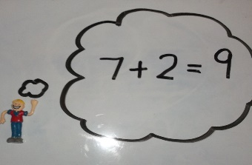 | 4)  Add a single digit to a 2-digit number up to 20 with a numberline  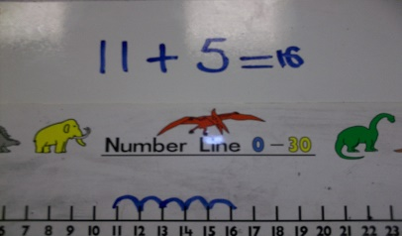
5)  Add a single digit to a 2-digit number up to 20 with a numberline  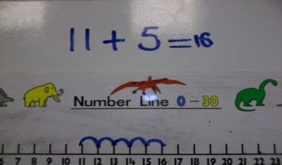 | 6)  Partitioning up to 50 – no bridging  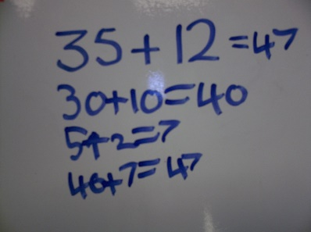
7)  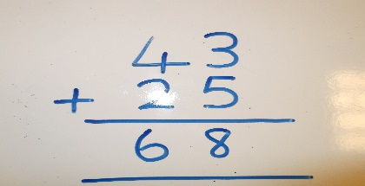  Adding 2 2-digit numbers using column method with no ‘carrying’. | 8) YEAR 4  Expanded column addition TU with multibase if required  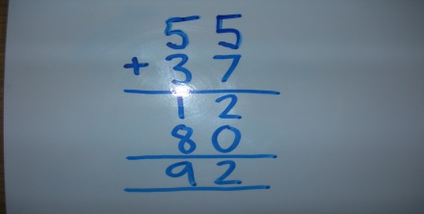
9)  Compact column addition of 2 3-digit numbers  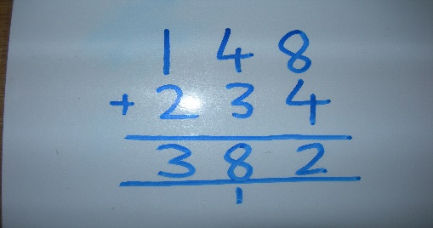 | 10)  Compact column addition of 2 4-digit numbers  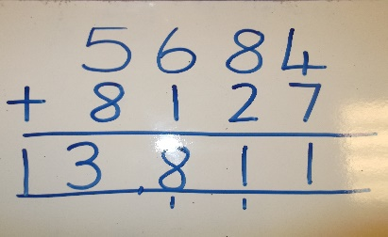
11)  Compact column addition of decimals to 2decimal places.  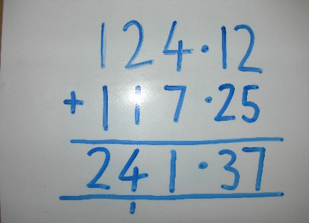 | 12)  Compact column addition of 2 5-digit numbers  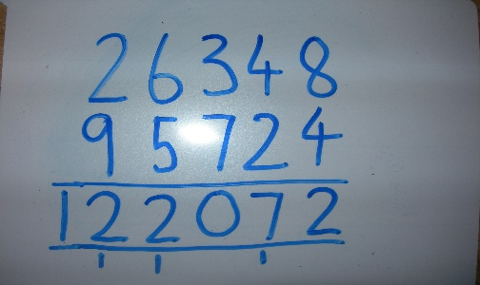
13)

Column column addition up to 3 decimal places



