Melling Primary School Calculations Progressions
DIVISION
1)  Halving up to 10  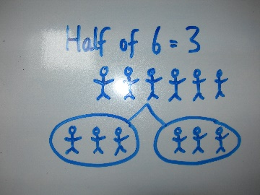 | 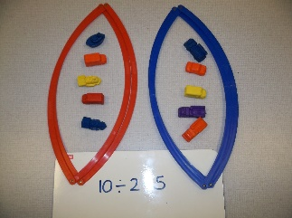  2)  Using concrete objects to divide up to 20
3)  Using concrete objects to divide up to 50  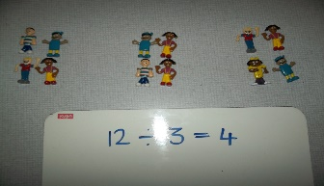 | 4)  Informal method of sharing up to 100  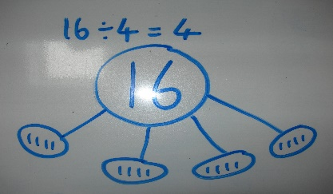
5)  Short division by 2,3,4 and 5 with carrying  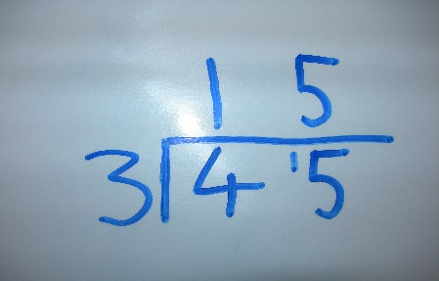 | 6)  Short division method by 2,3,4,5,6,8, with carrying  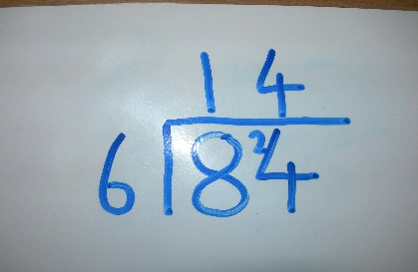
7)  Short division method by any single digit with carrying  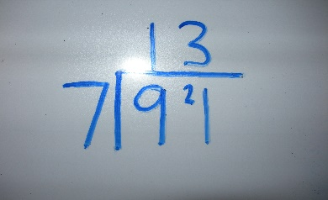 | 8) YEAR 4  Short division by any single digit with remainders  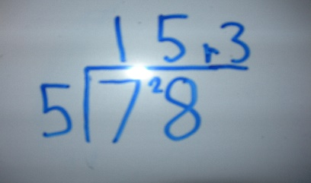
9)  Short division of a 3-digit number by a single digit  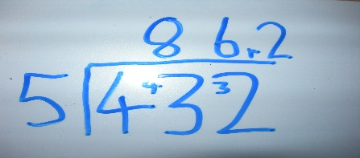 | 10)  Short division of a 4-digit by a single digit  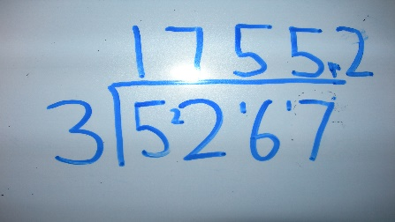
11)  Long division by a 2 digit number by chunking  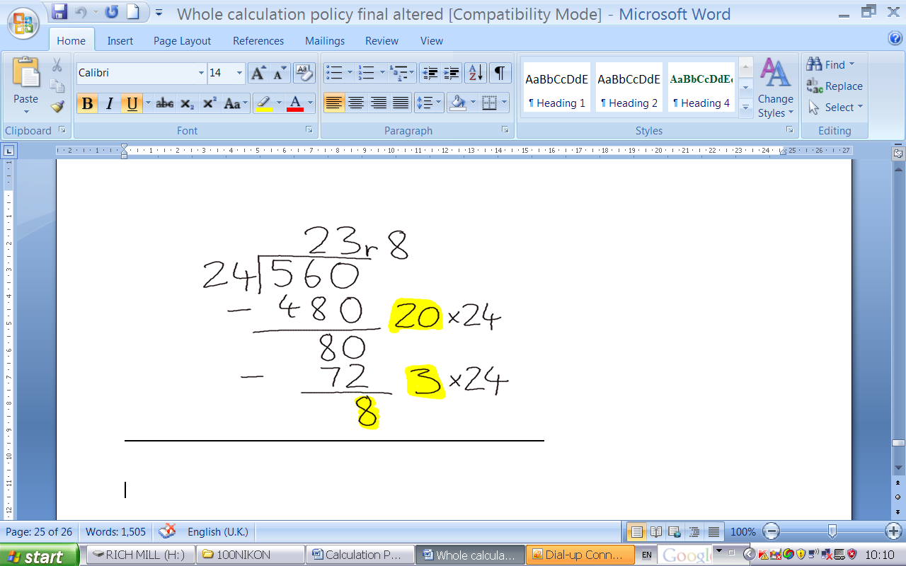 | 12)  Divide a number with 2decimal places by a single digit  

