Melling Primary School Calculations Progressions
SUBTRACTION
1)  Taking away objects from a set up to 10  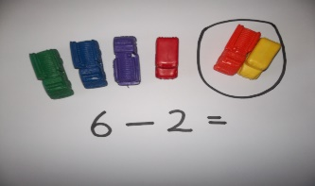 | 2)  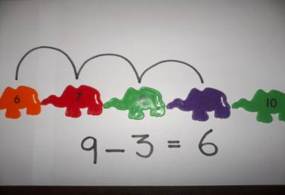  Subtract using a numberline from up to 20 and beginning to record
3)  Subtract by counting back from up to 10 without a numberline  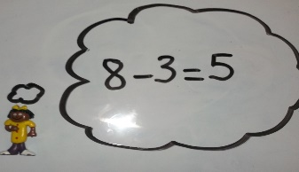 | 4)  Subtract a single digit from a 2-digit number up to 20 with a numberline  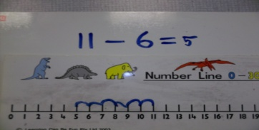
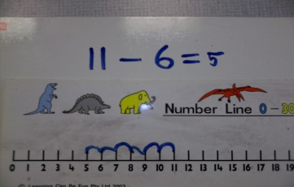  5)  Subtract a single digit from a 2-digit number up to 20 with a numberline | 6)  Subtract by counting on with a number line  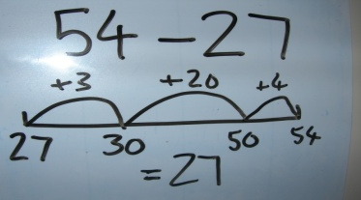
7)  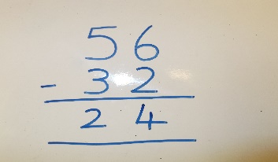  Column subtraction of 2 2-digit numbers with no ‘exchanging’. | 8) YEAR 4  Column subtraction of 2 2 digit numbers with exchanging  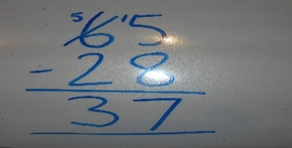
9)  Column subtraction of 2 3-digit numbers with exchanging  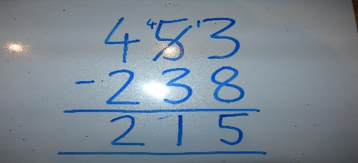 | 10)  Column subtraction of 2 4-digit numbers  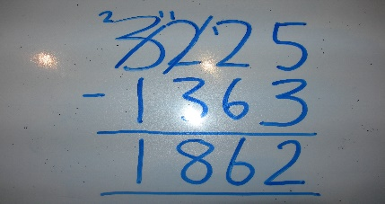
11)  Column subtraction of decimals to 2 decimal places.  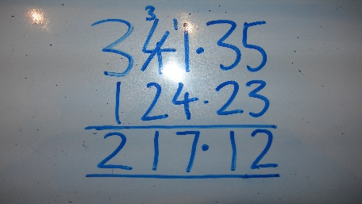 | 12)  Column subtraction of 2 5-digit numbers  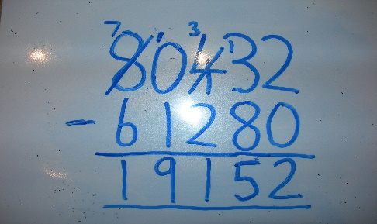
13)

Column subtraction up to 3 decimal places



